# Conclusions

1. Crowdfunded theater, specifically plays, were the most successful projects in the dataset.
2. Crowdfunding during the early summer months resulted in greater success rates.
3. Projects with goals of approximately $15,000 to $35,000 had a higher rate of success.

Some limitations of the data set include:

* Lack of data regarding the individual crowdfunding platform
* Lack of clarity regarding the definitions of variables such as country (is it the country the project was started in, or the nationality of the backers, etc.)
* Lack of analysis of the duration of the campaigns (though this could be generated using date data provided in columns launched_at and deadline)
* The data seem to be derived from information collected over a ten-year period and do not take into consideration the number of crowdfunding sites, economic conditions of the country at the time of the campaign, etc.
* Minimum and maximum individual pledge data would be helpful in accounting for variance and success or failure of different projects.

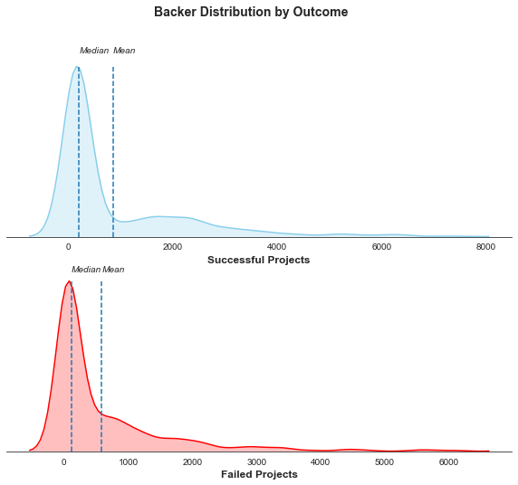Mean vs Median

Given that the mean and the median of successful and failed projects in the dataset are substantially different, it is likely that the data are skewed. This is because the accuracy of the two as measures of central tendency depend on the existence of outliers and the overall distribution of the data. If there are outliers and the information is skewed, the median is the better measure of central tendency. In addition, the presence of very high variance values for both successful and failed projects indicates the data is highly spread out from the mean, suggesting the mean is likely significantly influenced by outliers. This is further evidence that the median is a better measure of central tendency. The distplots above demonstrate this.

Variability

Based on the analysis in sheet Statistical_Analysis of the CrowdfundingBook workbook, the variability in the number of backers of failed crowdfunded projects in the dataset is just over half (57%) of the variability in the number of backers of successful crowdfunded projects in the dataset. This makes sense in that, given a standard minimum pledge, the greater the number of people pledging money to reach a goal, the greater the likelihood of reaching that goal. This also makes sense in that the difference between the maximum number of backers for successful projects and the maximum number of backers for failed projects was significantly greater than the difference between the means for both, resulting in more significant outliers for successful projects than failed projects.